HarvestEye interview prep

**Who is HarvestEye**

Harvest Eye was developed by CMV for B-hive, who then patented the technology in collaboration with CMV, and now B-Hive / Branston have established a new company, [HarvestEye Ltd](https://cityx.co.uk/2019/11/harvesteye-ltd-partners-with-grimme-uk-to-provide-crop-information-at-the-time-of-harvest/), to supply the HarvestEye technology to Grimme,a major manufacturer of root crop harvesters.

An IT services and It consulting company that specialises in creating innovative vision technology that sees root crop as they are harvested. Specifically HarvestEye is the potato harvester based data capture system that provides insight on size, count and crop variation on unwashed potatoes as they are harvested. The integrated data analytics shows precisely what is being lifted and from where in the field, insights that will help maximise marketable yield and reduce crop imbalance.

**What attracts me to HarvestEye**

The first Paragraph of the job Specification is very appealing to me: the idea of innovation and technology being essential to economic and environmentally sustainable food production for this generation and for future generations. Our mission is to create novel Agri-tech solutions to reduce food and energy waste, increase marketable yield, and enhance produce quality. Very much necessary given the state of the world: Last week there was an article by the Economist on the fact that there is “a world grain shortage putting tens of millions at risk” The world just has 10 weeks’ worth of wheat after Ukraine war as synonymously reported by the Telegraph.

They are a company that is seeking to produce technologies for the benefit of Farmers and by extension the UK public. I have been attracted by the opportunity to apply myself to something I think is noble, necessary and done with the sole benefit of others in mind. Moreover the feedback on your website supports this fact as well. You have genuinely positive feedback on the inclusion of harvest eye technology in the farming industry and this says a lot about Harvest eye as a company. It shows that what is being done at Harvest Eye is meaningful

A sample of Projects done in each language (Pre MSc)

**Java**

During my Extended Diploma in IT at North Kent College I created GUI calculate for calculating the paint cost for a room with x,y,z dimensions. I split my code into multiple procedures because the amount of code required for each section would be too much to all run in one go. It could cause mistakes in the code and there would simply just be too much code to run through. I used methods and split my code into different classes. A method for each of the paints, the calculations and the undercoat. I then call the methods independently depending on the options the user choses based on a class of switch statements.

**C#**

In my First year of Computer Science at the University of Lincoln I took part in a game jam where I created a game using C# in 24-hours using the Unity cross platform game engine. The goal of the game was to pick up items which would reveal the paths to take to get to complete each level of the game. I used open source libraries to get a character model and programmed the character to move using an open source character controller. The Game assets were also openly available but the environment was put together purely by my imagination.

**Python**

In my second year of Computer Science at the University of Lincoln I lead a team of students to program a robot to play a game of match the cards with a human, in a simulated environment. The project was split into two subprograms, a computer vision program that allowed the robot to see cards and their details and write those details to a text file, and a simulation to simulate the robot pointing at the card locations. The simulation was written in python using the qiBullet simulation tool and utilised a robot referred to as “Pepper”. The robot was programmed to detect and read in details from cards such as their numbers, symbols, and colour as well as grid positions and then use this information to create an array of their positions for accurate pointing of their locations. The robot was programmed to point at the card locations by converting the x and y coordinates in radians that the joints of the robot arm could be positioned into automatically when it was the robot’s turn to point at a card.

**C++**

During my third year in Computer Science at the University of Lincoln, my dissertation project was improving on an existing research project that was based on simulating the movements on a swarm of robots called turtlebots. This swarm simulation was based on the Lennard-Jones potential and was written in C++ but simulated using a multi-physics robot simulator called ARGoS simulation. The improvements I made included implementing obstacle avoidance to enable the robots to move around obstacles in their paths and get to a goal state much sooner, implementing conditional statements for when obstacle avoidance was necessary and when exploration mode was necessary, this allowed the robots to look for exists when they were separated from the swarm and act independently, a behaviour that was not present before I modified the original code. I demonstrated the results of this in comparison to the original algorithm in MATLAB with a series of boxplots and bar charts along with video comparisons of the simulations running simultaneously

**Machine Learning Experience**

Pneumonia Classicication

Supermario Bros training

Solving a polynomial regression task on a 1-dimentional dataset which was generated form an unknown polynomial function along with noise. I had to analyse the performance of the regression algorithm fitting the data and estimate the degree of the polynomial as well as its parameters. This was analyses using RSME

**Artificial Intelligence**

implementation of solutions to  
AI planning problems using PDDL (the Planning Domain Definition  
Language). The task was to program a rumba to Clean floor tiles

**Advanced Artificial Intelligence**

**Assignment 1**

Creating CPT tables for a given dataset and implementing a python program that read in the dataset and automatically computed the intervention probability for all values of the dataset

Lastly I had to calculate the average casual effect of an added gene to the dataset

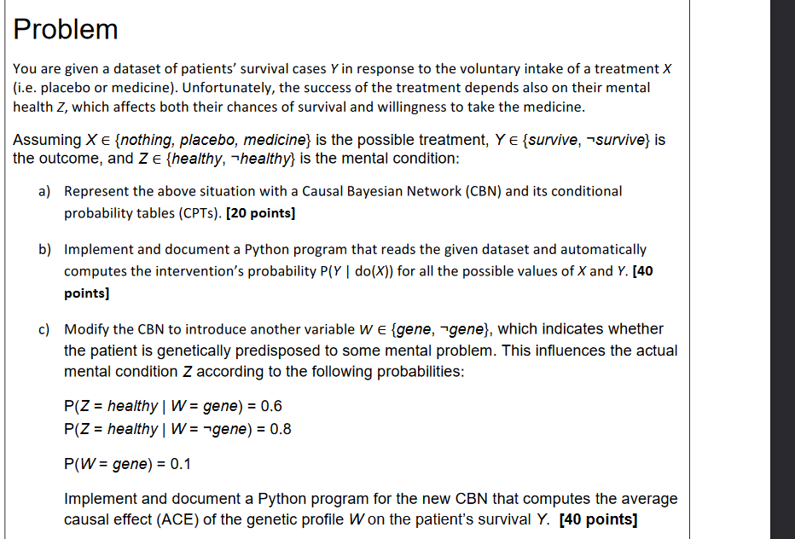

Assignment 2

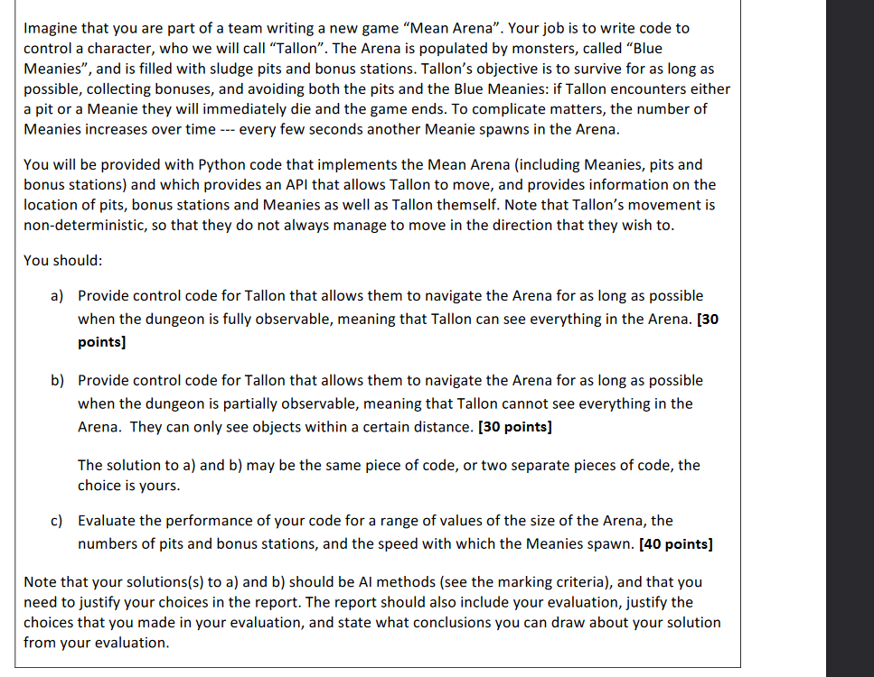

**SCADA**

**What am I looking to achieve in a new role for embedded software development (MOTIVATION)**

I am looking to challenge myself and really learn about how embedded software is written and implemented in industry. It both excites and makes me feel anxious to apply for such a role but I have always been intrigued by videos on how stuff works and I have always found the embedded software aspect of engineering really cool and an admirable job to have. I think taking on the role would be an amazing chance for me to apply the skills I have learnt in machine learning as well as improve on them.

**What is embedded software?**

Computer software written to control machine, low level code such as assembly language that directly tells machines what to do. It is specialised for specific pieces of hardware that is both time and memory dependent. Use cases could be in booting and interrupt handling.

Code for such systems are typically written in C++, or C but high level languages such as Java, Python and JavaScript are also commonly used in microcontrollers and embedded systems.

**Assembly language**

Any low level language that is converted by an assembler. Assembly language is designed to be readable by humans and intended to communicate directly with a computer’s hardware, unlike machine code which consists of 1s and 0s and hexadecimal characters. Assembly language allows the movement of data and instructions between memory locations and registers and there are various commands such as load that can be used.

Questions for HarvestEye

1. 1 On your wesbsite the keywords are:
   * Insight
   * Efficiency
   * Sustainability

With the idea of innovating root crop technology that sees crops as they are harvested. I am really interested in knowing more about how the three main points are achieved

1. What does the company aim to achieve in the future, what are your goals?
2. What aspects of the company are you most looking to develop
3. What is the reason for Vacancy?
4. What career progressions are there?

What have you learnt from previous Job?

The importance of teamwork, structure and good leadership when tacking problems and striving to reach objectives. In my previous role as a Strawberry Technician I worked with another student who had a background in agri-food technology where as my background was in computer science. The Job was very straightforward and lacked the necessity for application of skills I had at the time. The introduction of an experienced team leader gave our team the opportunity to take on more challenges such as data collection on certain aspects of strawberries that would be sent to researchers for testing.

Who is HarvestEye:

<https://blogs.uwe.ac.uk/engineering/machine-vision-impacts-farming/>

END of INTERVIEW

Could I have some feedback?

What are the next stages?

Accept any offer on the spot or be tactful and give a date for a decision

Call agent immediately after